Expansion Testing Machine 2.0

Contents

1.Introduction : 2

2.TEST: 4

5.REPORTS: 5

List Reports: 5

Print Report: 6

Email Report: 7

View –PDF Report: 8

6.SETTING: 9

Setup-Email: 9

7.CPU: 12

8.CONTROLER DEVICE: 13

# 1.Introduction :

Following is the block diagram for the expansion testing software.

CPU

**USB to RS232 Connection:**

Controller

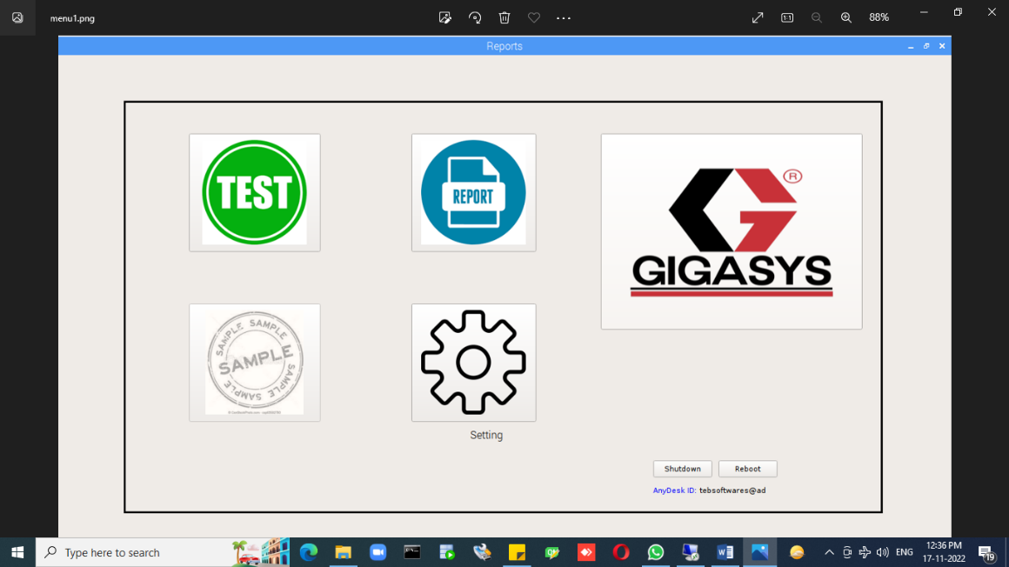

# 2.TEST:

# 

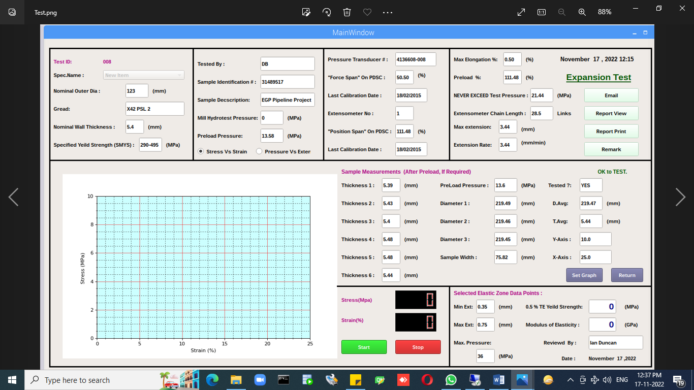

# 5.REPORTS:

# List Reports:

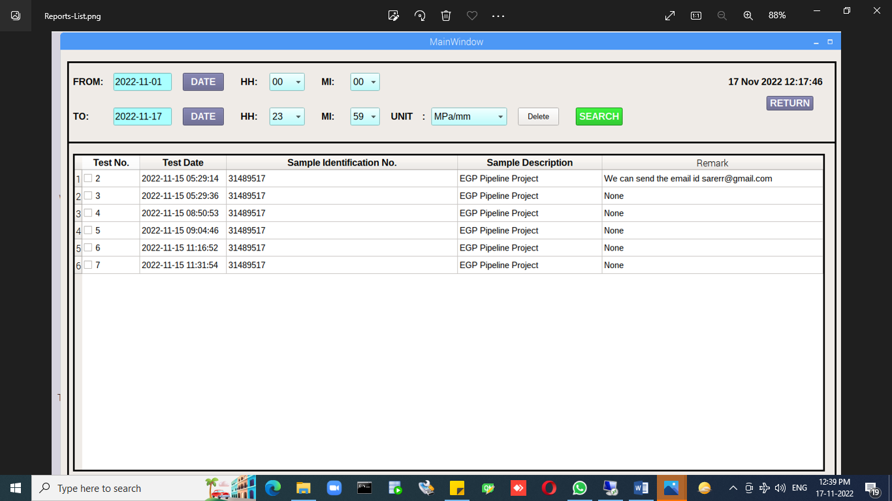

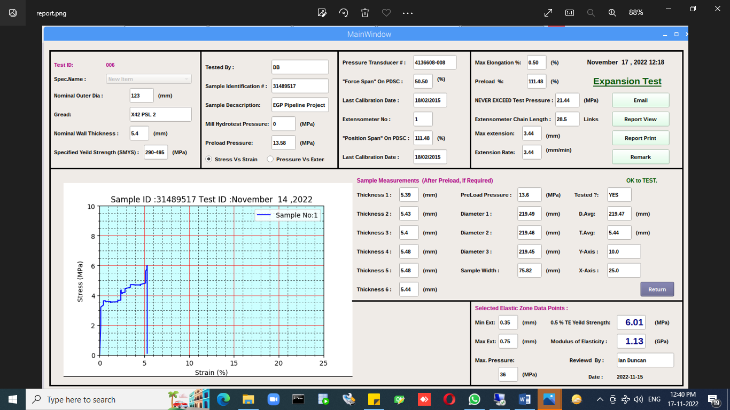

# Print Report:

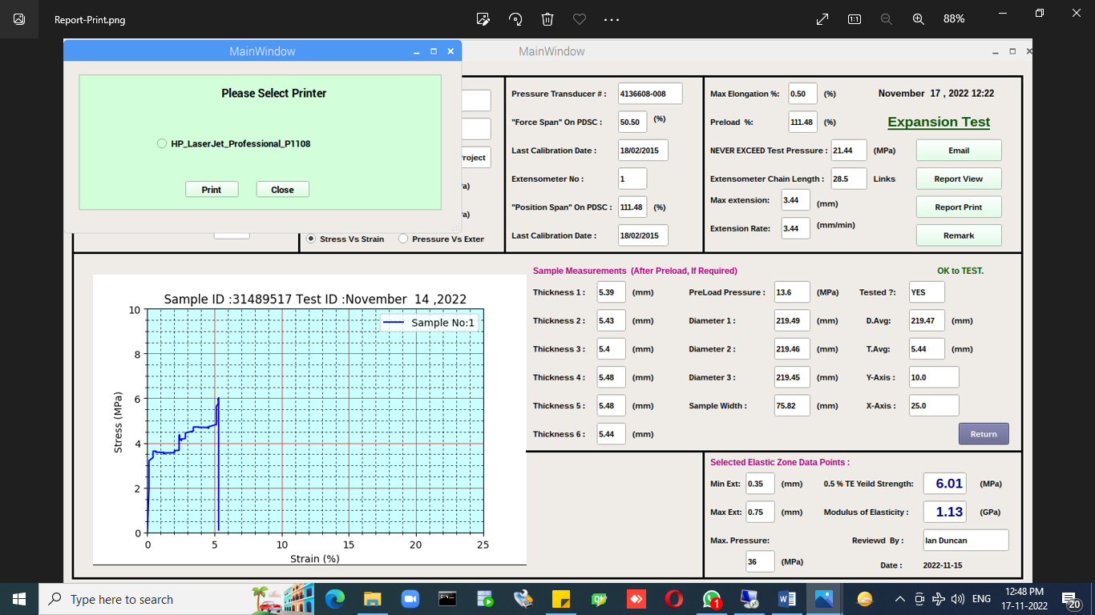

# Email Report:

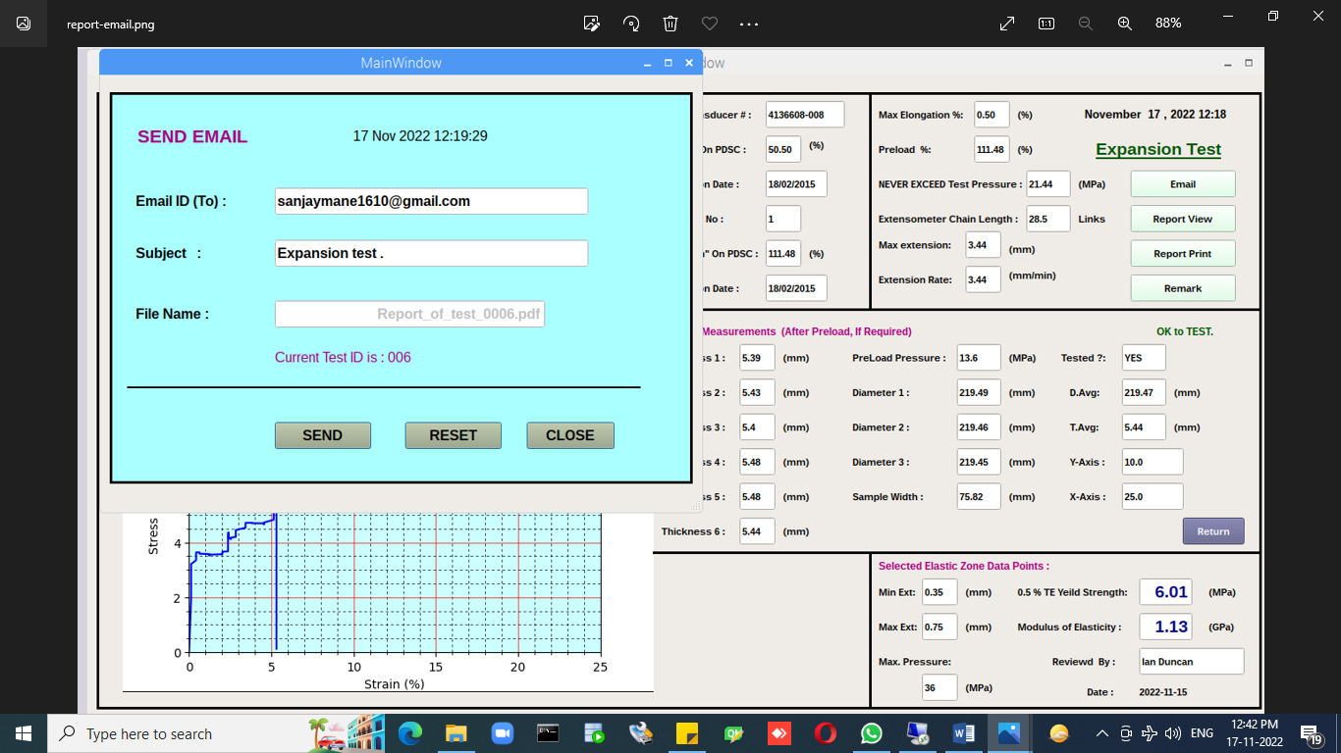

# View –PDF Report:

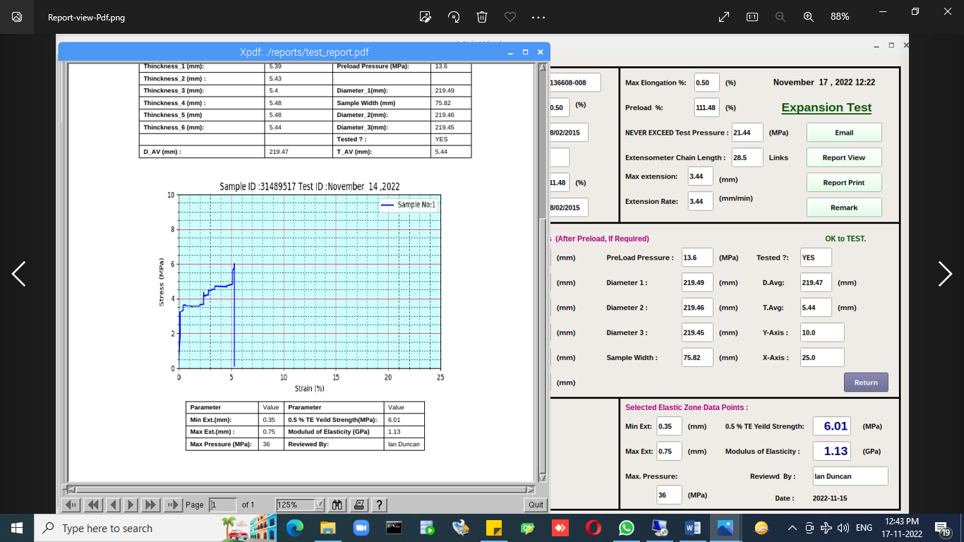

Add Remark:

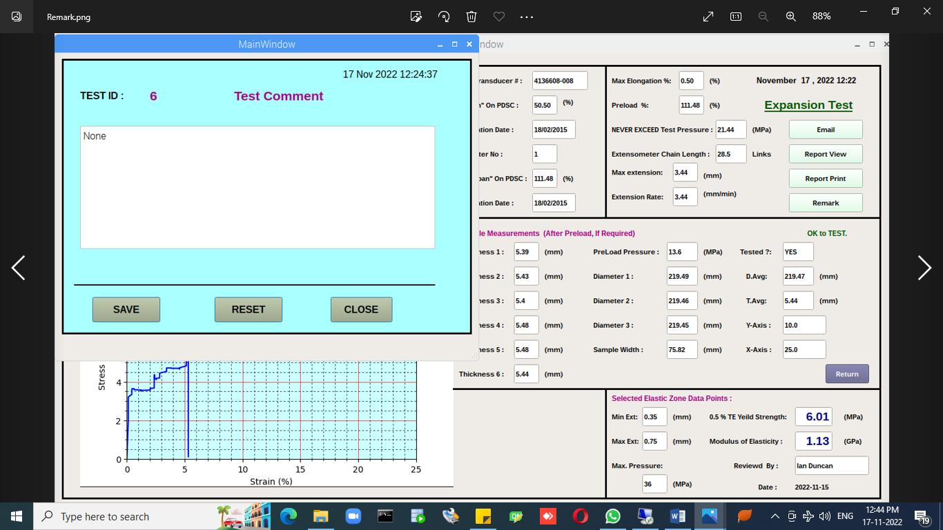

# 6.SETTING:

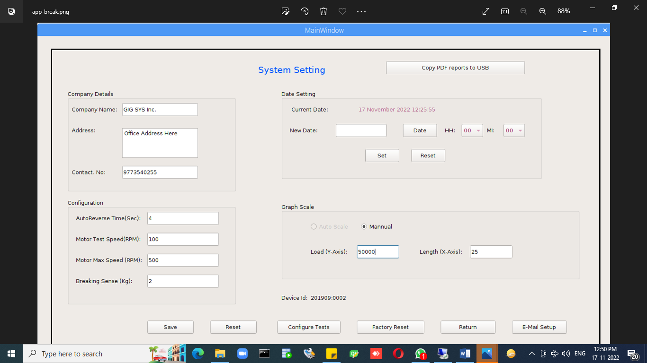

# Setup-Email:

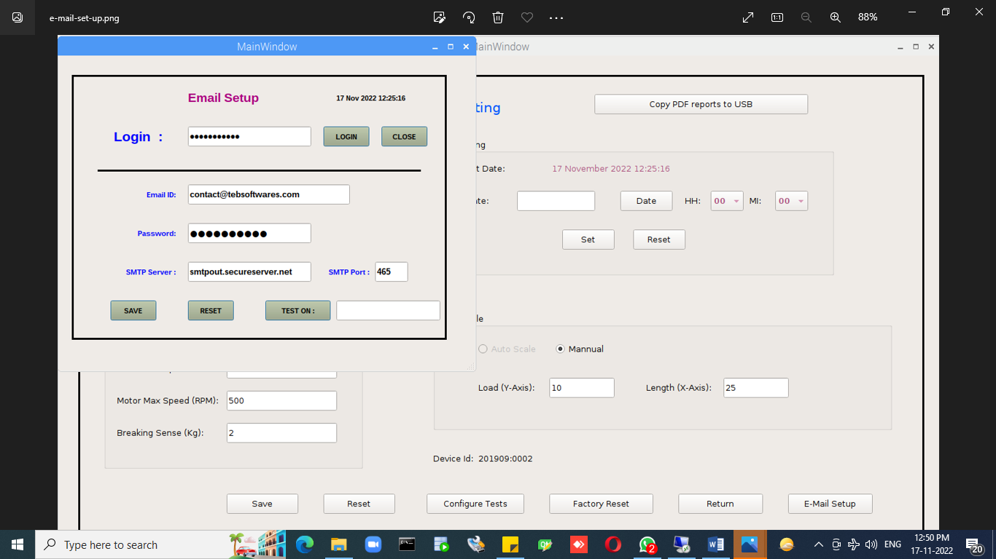

How to Break App:

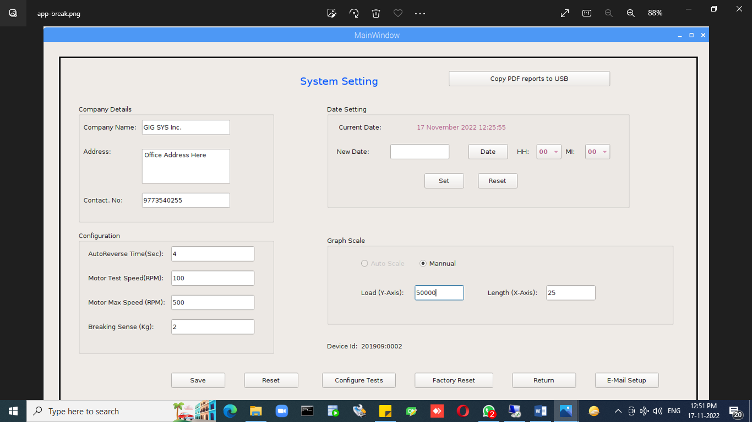

Click on “Config Test” button.

Manual Reboot:

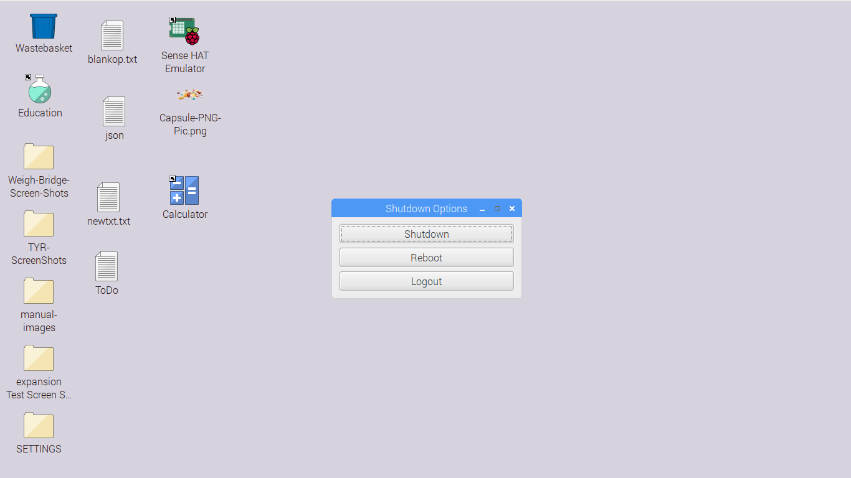

Wifi setup:

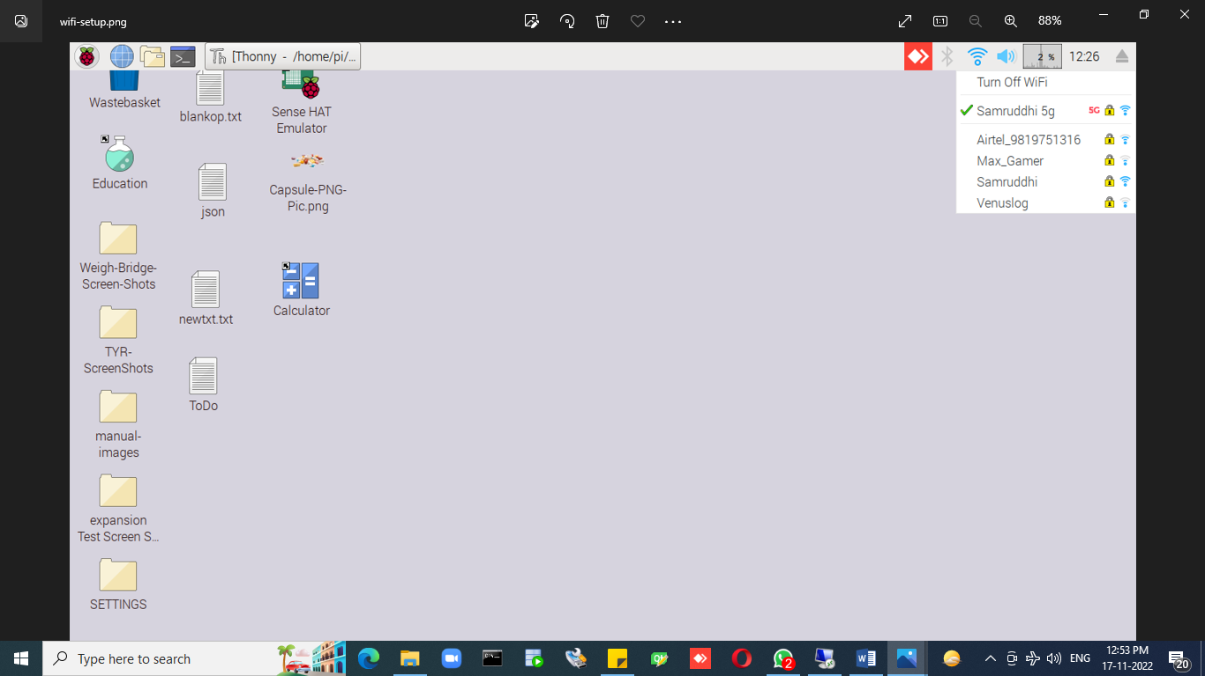

Anydesk Id:

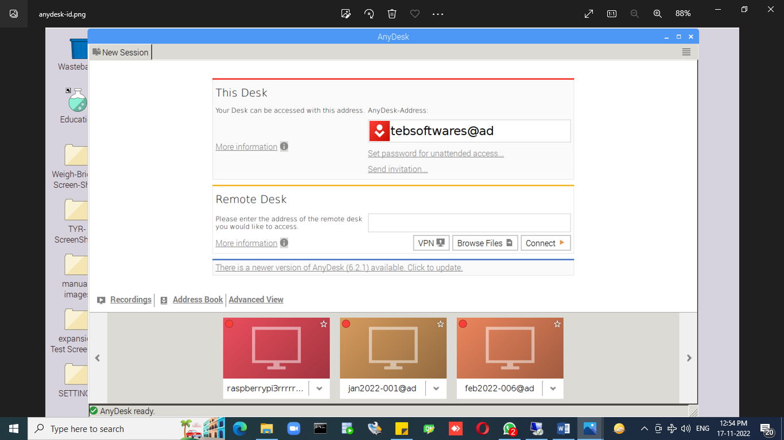

# 7.CPU:

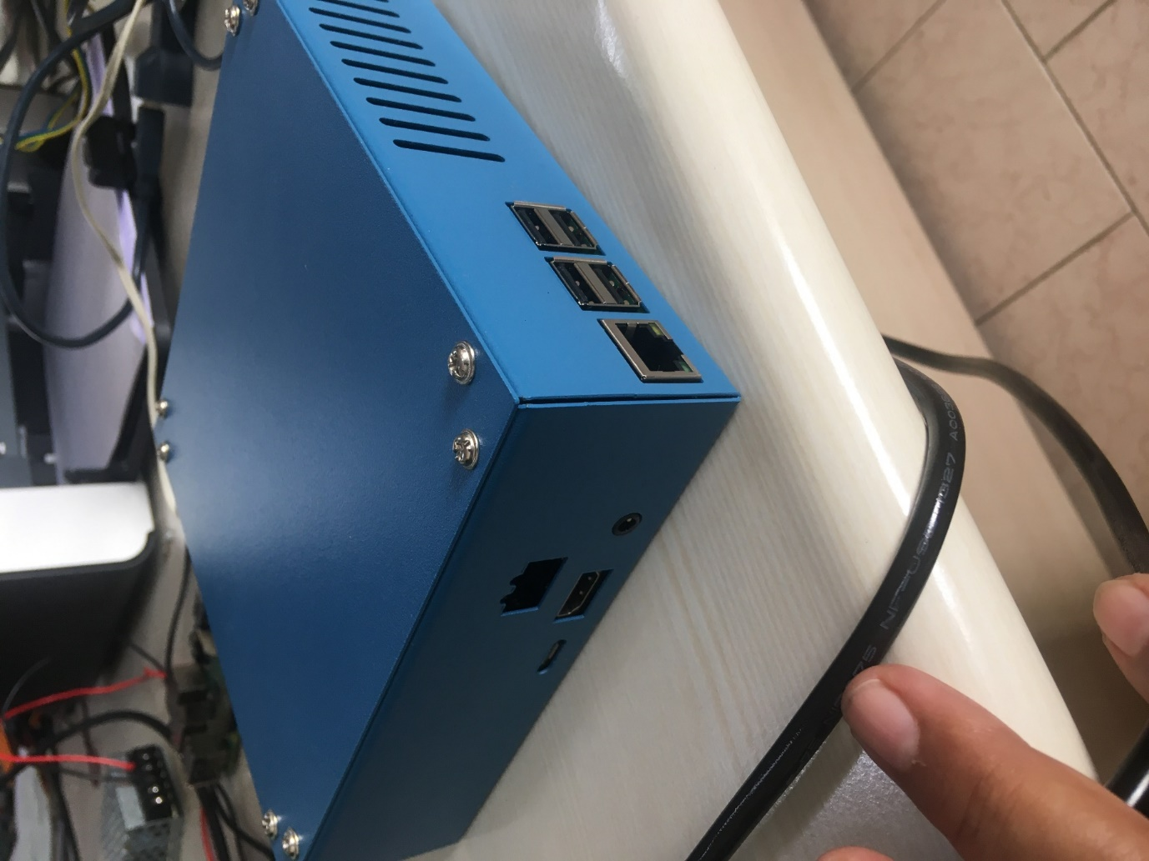

# 8.CONTROLER DEVICE:

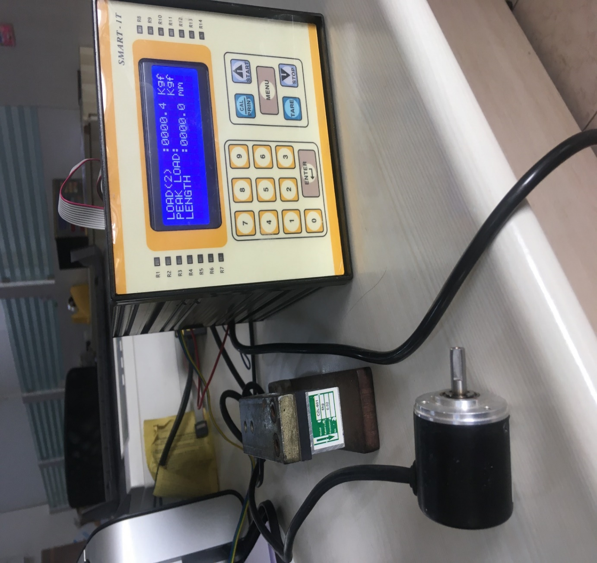

Hardware Connection Ports details:

**Load Calibration sensor:**

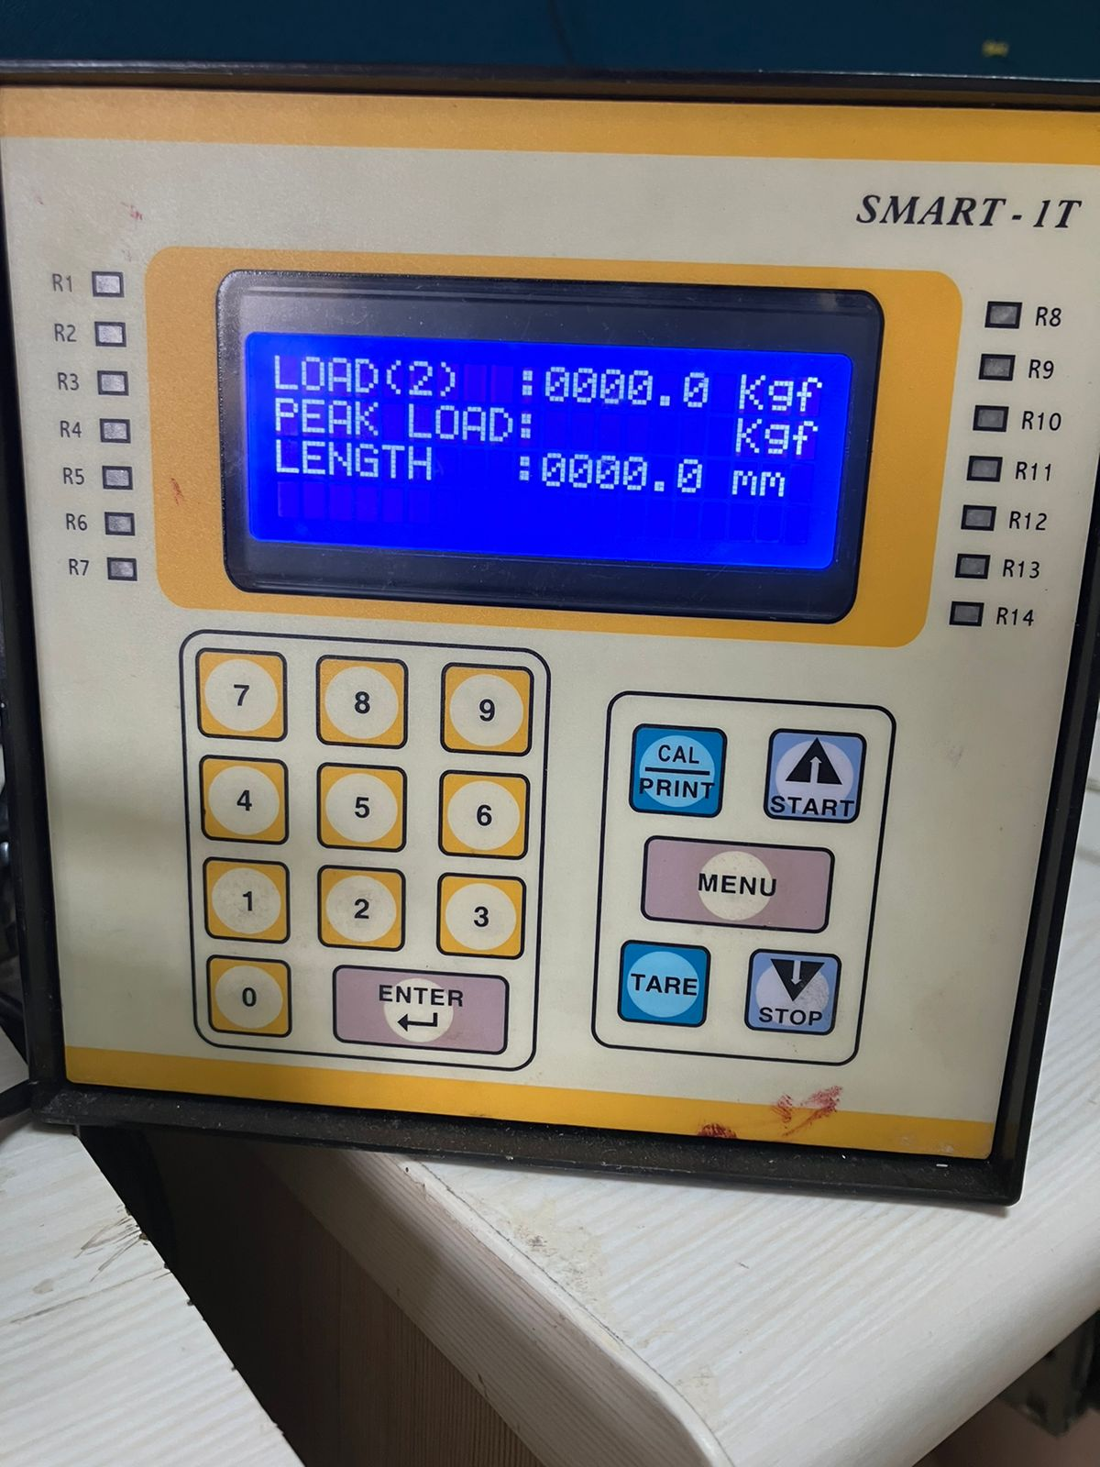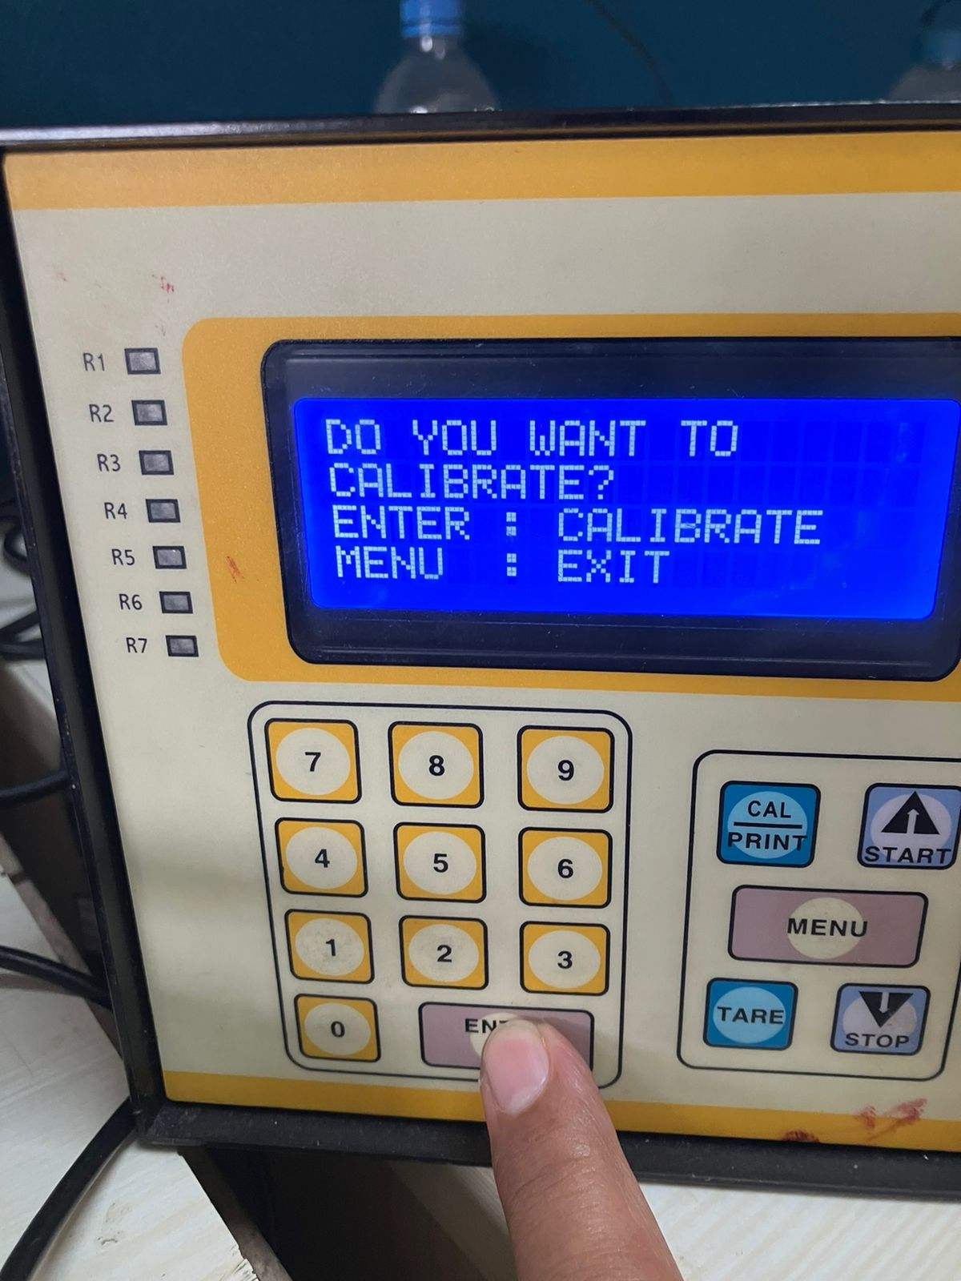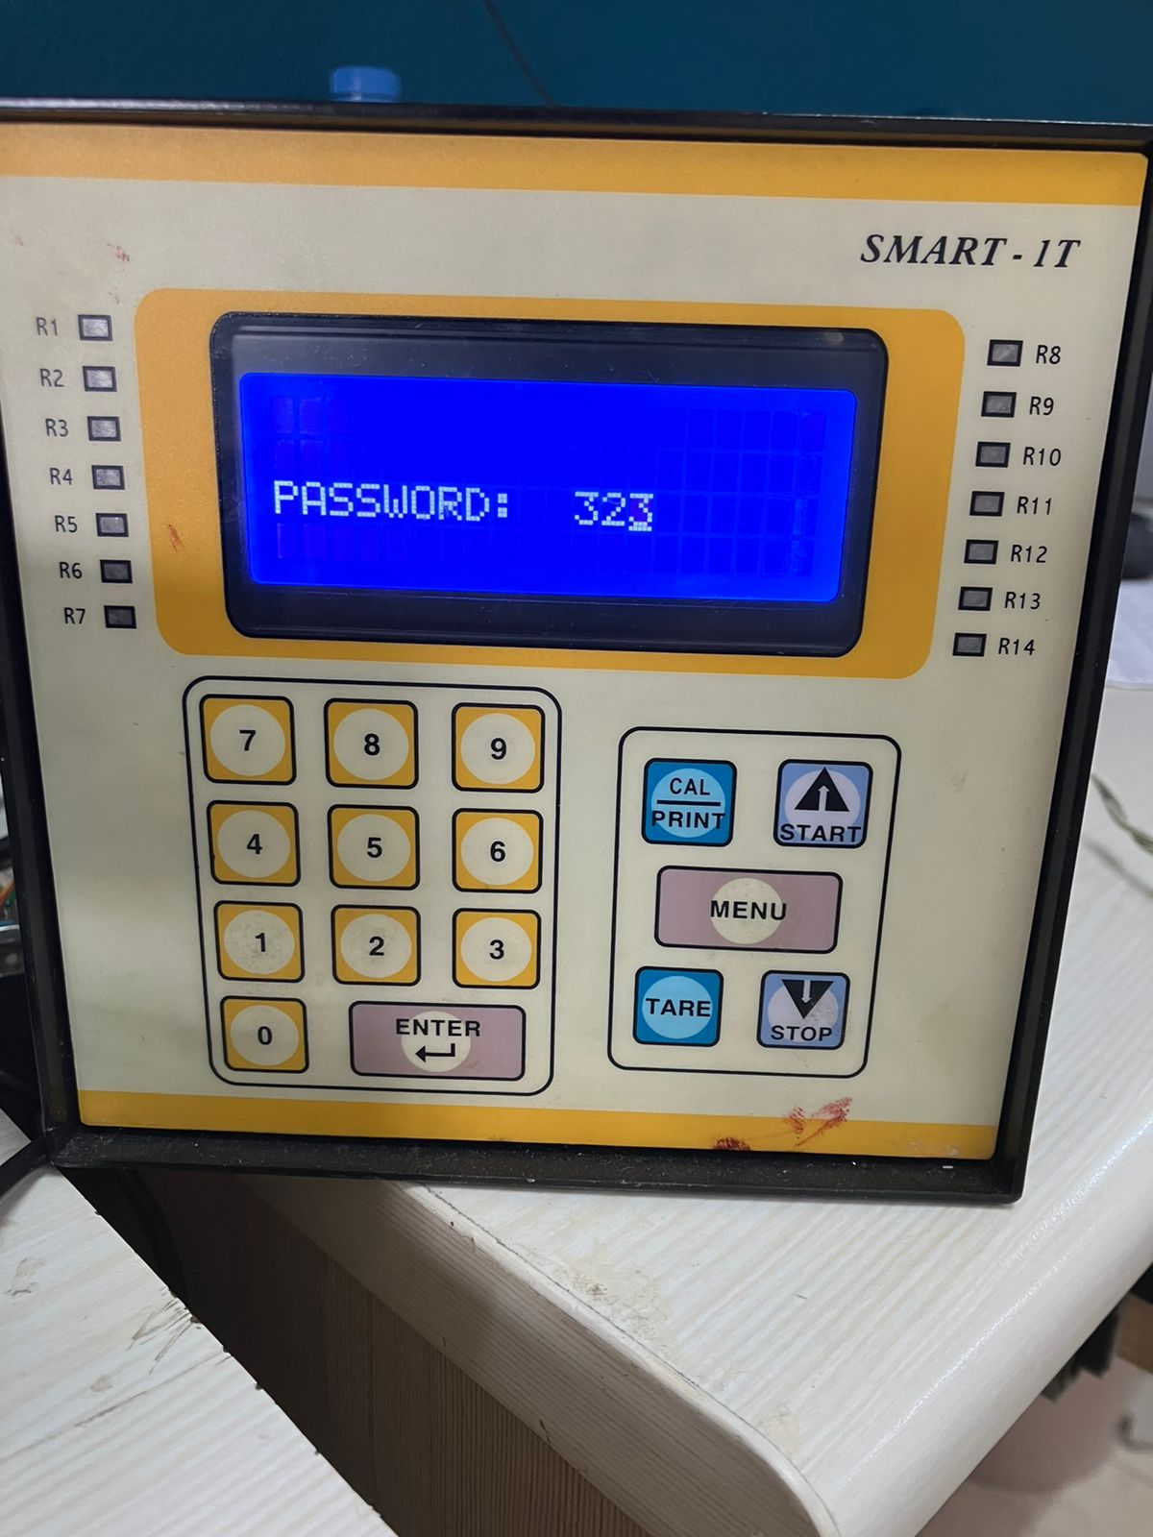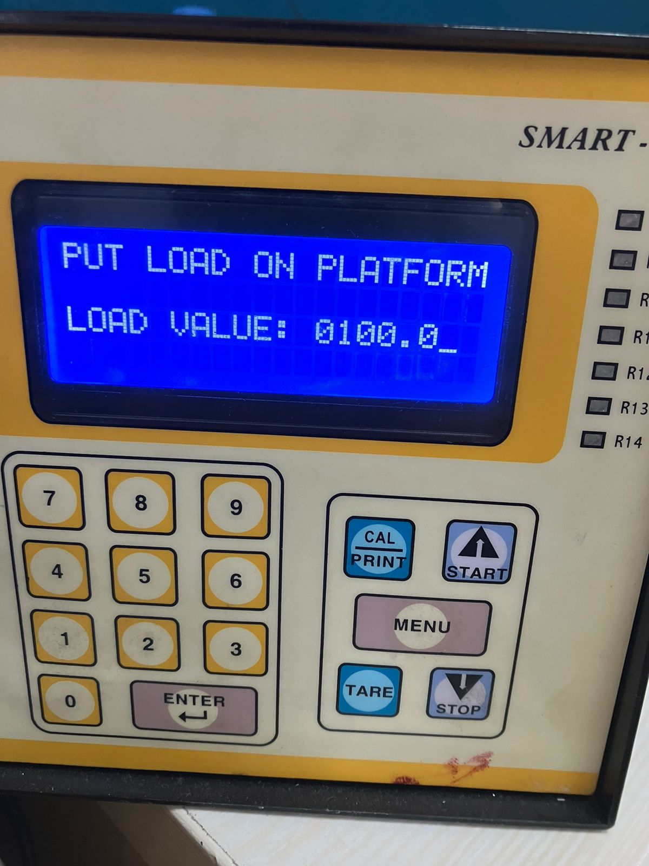

EXPANSION Testing Machine

Wiring Details.

|  |  |  |  |  |
| --- | --- | --- | --- | --- |
| INPUT-1 | | | | |
|  |  |  |  |  |

|  |  |  |  |
| --- | --- | --- | --- |
| LOAD CELL | | | |
| Ex+ | Op+ | Op- | Ex- |

|  |  |  |  |  |
| --- | --- | --- | --- | --- |
| INPUT-2 | | | | |
|  |  | O/P | -V | +V |

Ex+ : Loadcell Positive Excitation O/P: Extensometer output

Op+: Loadcell Positive Output -V: Negative (Com) for Extensometer

Op- : Loadcell Negative Output +V: Positive (+12V) voltage for Extensometer

Ex+ : Loadcell Negative Excitation